# Kanban – Tasks by Date

The prebuilt *Kanban – Tasks by Date* provides an overview of registered tasks in your NetSuite account, with each Kanban column representing a task status in relation to the task due date. The first column contains one Kanban column, *Passed Due*, showing all uncompleted tasks where due date is passed. Using this Kanban users can act on uncompleted tasks that either passed due date or due date is close. It also allows the tasks to be rescheduled to a later due date by simply drag the card to desired column. The column *Completed* only shows tasks completed within this week.

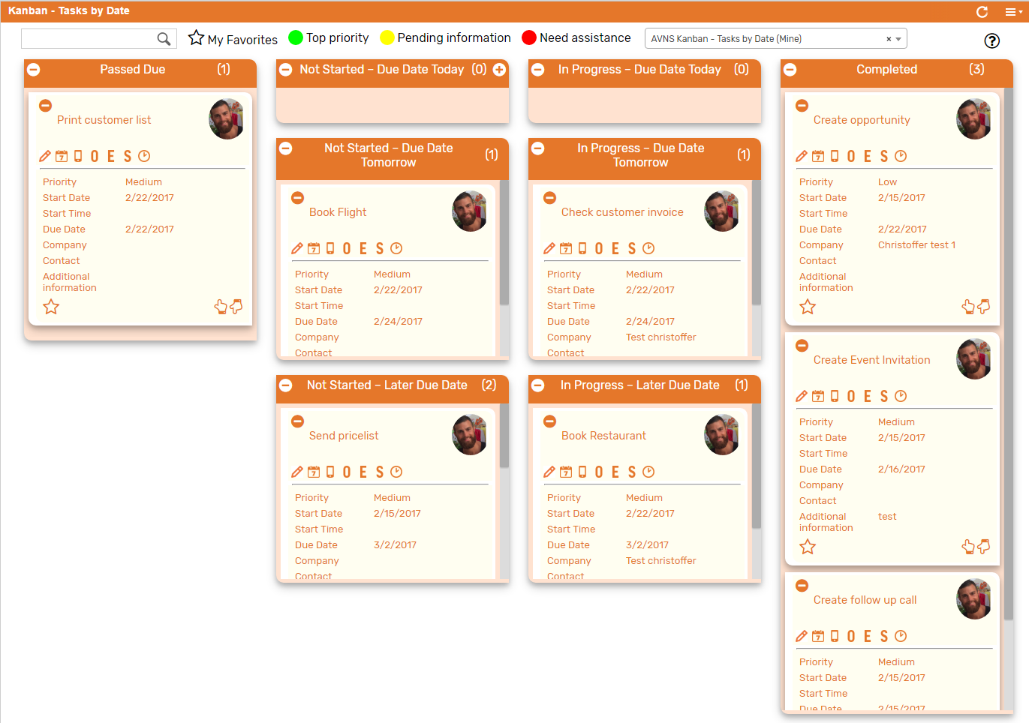

### Kanban – Tasks by Date: Prerequisites

Before using the *Kanban – Tasks by Date*, please make sure the prerequisites listed below are fulfilled in order for the board to function as expected.

1. **Sales Rep & Sales Rep Image**  
   Make sure to mark the checkbox ‘Sales Rep’ on the Employee record for all available Sales Reps.   
   If an image has been uploaded to the *Image* field on the Employee record, this image will be displayed on the Kanban card. If no image is available, a predefined profile icon will be displayed instead.

### 

### Kanban – Tasks by Date: Card Moves & Column Actions

The *Kanban – Tasks by Date* board contains eight Kanban Columns. Each column has been configured with none or several Column Actions. Double clicking on any card in the *Kanban – Tasks by Date* board will open the task record in edit mode.



1. **Passed Due**
   1. *Card Moves* – Kanban cards in the column *Passed Due* can be moved to all other columns in the Kanban board.
   2. *Column Actions* – No column actions is created for column *Passed Due*. Cards will automatically be placed here when task status is *Not Started* or *In Progre*ss and task due date is passed.

1. **Not Started – Due Date Today**
   1. *Card Moves* – Kanban cards in the column *Not Started – Due Date Today* can be moved to all other columns in the Kanban board except *Passed Due*.
   2. *Column Actions* – when moving a Kanban card to the column *Not Started – Due Date Today* the status of the record represented in the Kanban card will be updated to *Not Started* and the due date will be set to today.
   3. *Add Card* –It is possible to add a Kanban card (a new record) from the column *Not Started – Due Date Today* by clicking on the + icon in the top right corner of the column.
2. **In Progress – Due Date Today**
   1. *Card Moves* – Kanban cards in the column *In Progress – Due Date Today* can be moved to all other columns in the Kanban board except *Passed Due*.
   2. *Column Actions* – when moving a Kanban card to the column *In Progress – Due Date Today* the status of the record represented in the Kanban card will be updated to *In Progress* and the due date will be set to today.

1. **Not Started – Due Date Tomorrow**
   1. *Card Moves* – Kanban cards in the column *Not Started – Due Date Tomorrow* can be moved to all other columns in the Kanban board except *Passed Due*.
   2. *Column Actions* – when moving a Kanban card to the column *Not Started – Due Date Tomorrow* the status of the record represented in the Kanban card will be updated to *Not Started* and the due date will be set to tomorrow.
2. **In Progress – Due Date Tomorrow**
   1. *Card Moves* – Kanban cards in the column *In Progress – Due Date Tomorrow* can be moved to all other columns in the Kanban board except *Passed Due*.
   2. *Column Actions* – when moving a Kanban card to the column *In Progress – Due Date Tomorrow* the status of the record represented in the Kanban card will be updated to *In Progress* and the due date will be set to tomorrow.
3. **Not Started – Later Due Date**
   1. *Card Moves* – Kanban cards in the column *Not Started – Later Due Date* can be moved to all other columns in the Kanban board except *Passed Due*.
   2. *Column Actions* – when moving a Kanban card to the column *Not Started – Later Due Date* the status of the record represented in the Kanban card will be updated to *Not Started* and the due date will be set to seven days from today.
4. **In Progress – Later Due Date**
   1. *Card Moves* – Kanban cards in the column *Not Started – Later Due Date* can be moved to all other columns in the Kanban board except *Passed Due*.
   2. *Column Actions* – when moving a Kanban card to the column *In Progress – Later Due Date* the status of the record represented in the Kanban card will be updated to *In Progress* and the due date will be set to seven days from today.
5. **Completed**
   1. *Card Moves* – Kanban cards in the column *Completed* cannot be moved to all other columns in the Kanban board.
   2. *Column Actions* – when moving a Kanban card to the column *Completed* the status of the record represented in the Kanban card will be updated to *Completed* and the date completed will be set to today.

### Kanban – Tasks by Date: Available Card Actions

The Kanban cards in the *Kanban – Tasks by Date* board each contains seven Card Actions.

1. 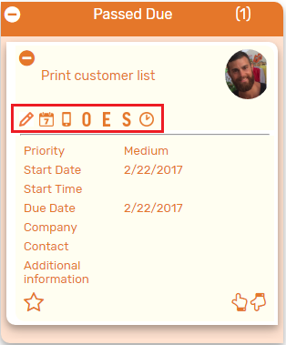**TASK: New Note**Add a new note to the task from the Kanban card.
2. **TASK: New Event**Create a new event from the Kanban card.
3. **TASK: New Phone Call**Create a new phone call from the Kanban card.
4. **TASK: New Opportunity**Create a new opportunity from the Kanban card.
5. **TASK: New Estimate**Create a new estimate from the Kanban card.
6. **TASK: New Sales Order**Create a new salesorder from the Kanban card.
7. **TASK: Enter Time**Add a time tracking record to the task from the Kanban card.

### Kanban – Tasks by Date: Alternative Searches

There are two alternative searches for the *Kanban – Tasks by Date* board.  
  
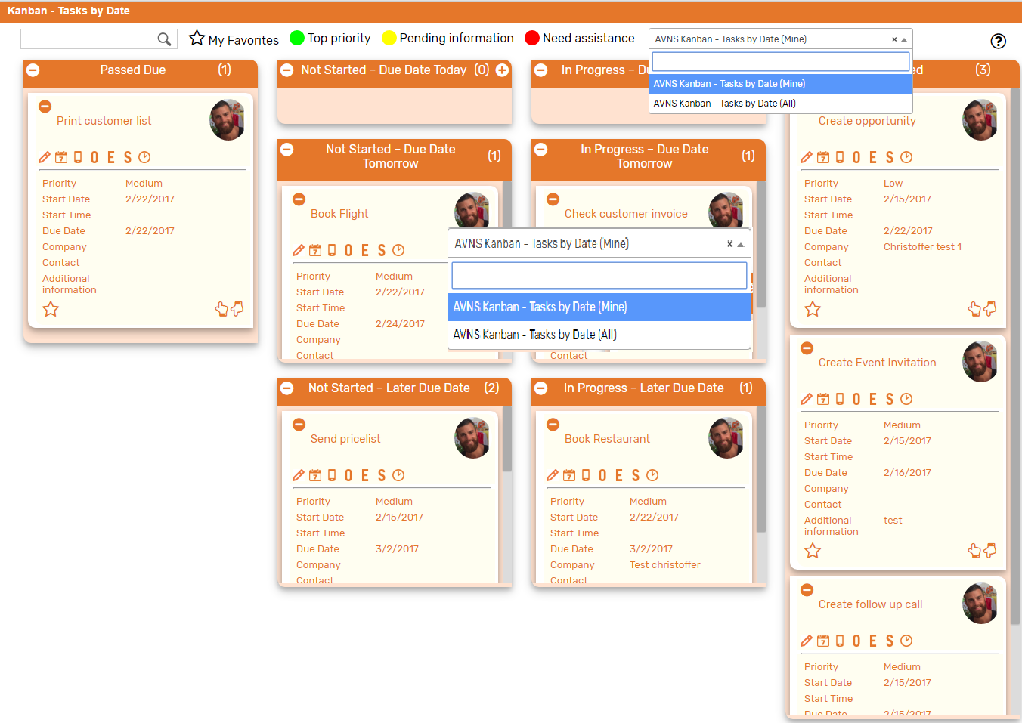

1. **AVNS Kanban – Tasks by Date (All)**This search will display all registered tasks in the *Kanban – Tasks by Date* board.
2. **AVNS Kanban – Tasks by Date (Mine)**This search will display registered tasks where assigned to is *Mine* (current user) in the *Kanban – Tasks by Date* board.

### Kanban – Tasks by Date: Available Colors

There are three colors available for the *Kanban – Tasks by Date* board, which can be used to highlight and filter the Kanban cards (*Top priority // Pending information // Need assistance*). These are defined in the *Color* subtab of the Kanban configuration record.

